**Lab 1.** **Create a Database & Table Using MySQL Command-Line Client.**

1)Create a database with the name StudentManagementSystem0

**Create a table with named Student with attributes:**

**StudentID (Primary key), FirstName, LastName, Gender, Email, Phone**



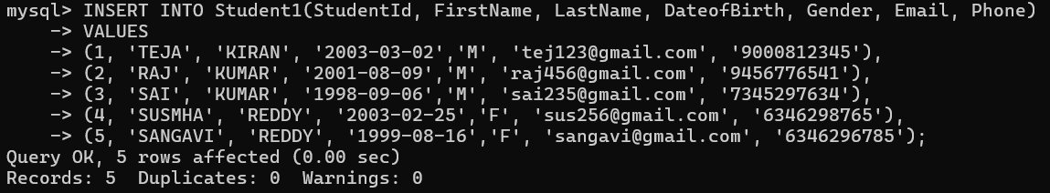

**Out Put 🡪**

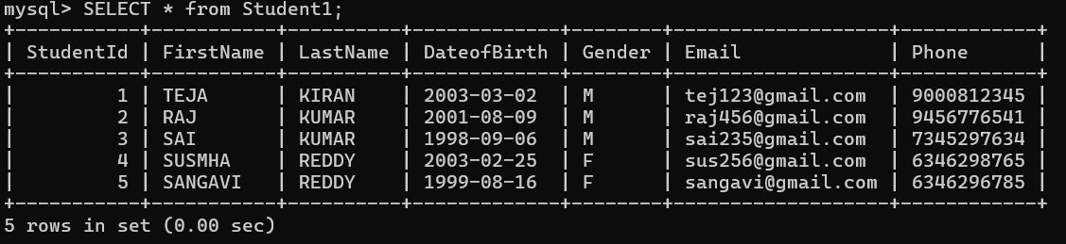

2) Create a table with name course with attributes:

CourseId (Primay Key), CourseTitle, Credits

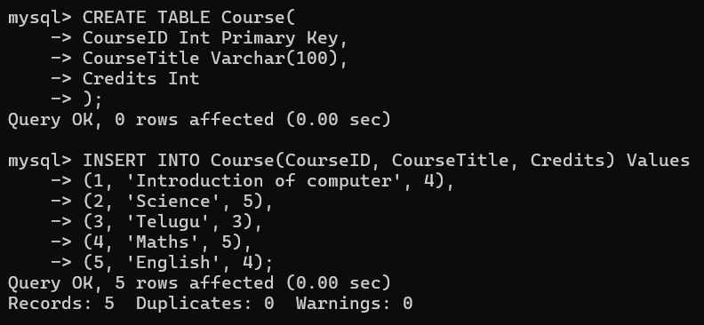OUTPUTà

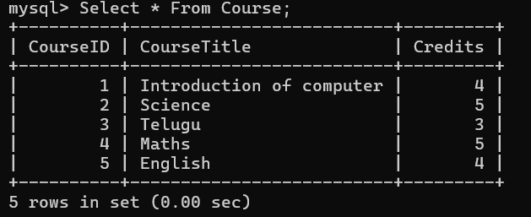

3) Create a table with named Instructor with attributes:

InstructorID (Primary Key), FirstName, LastName, Email

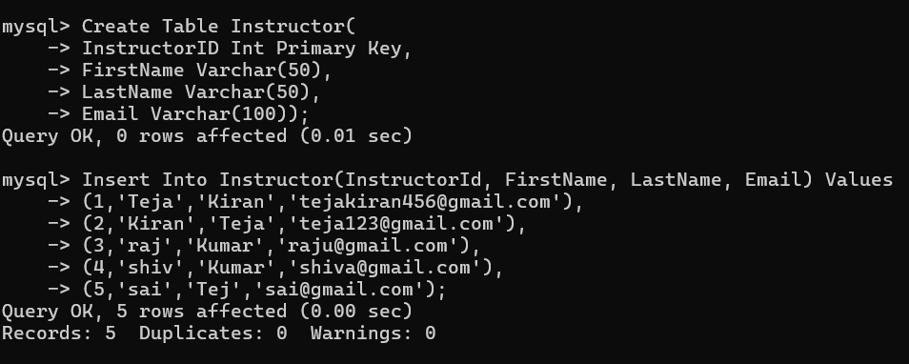

OutPut🡪

